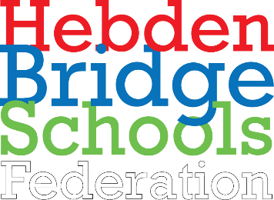 | 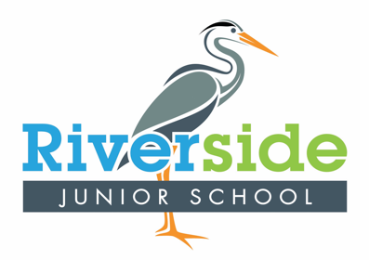 | Topic Overview Year 3 – Spring 1 2024
Key Texts English | The Girl Who Stole an Elephant
Subject | Science | Computing | Geography | History | Art & Design | Design & Technology | MFL | PE | RE
NC  Objectives / links | Pupils should be taught to:  - compare and group together different kinds of rocks on the basis of their appearance and simple physical properties  - describe in simple terms how fossils are formed when things that have lived are trapped within rock  - recognise that soils are made from rocks and organic matter  Vocabulary:  Key  Rock, fossil, Earth, crust, igneous rock, sedimentary rock, metamorphic rock, magma, lava  Sparkle  Geologist, geology, mantle, core, palaeontology, permeable, impermeable | Pupils should be taught to:  - Use search technologies effectively, appreciate how results are selected and ranked, and be discerning in evaluating digital content  - Select, use, and combine a variety of software (including internet services) on a range of digital devices to design and create a range of programs, systems, and content that accomplish given goals, including collecting, analysing, evaluating, and presenting data and information  Vocabulary:  Key  Text, image, message, document, software, publish, communicate, font, style, size, edit, backspace, shift, template, orientation, content | Place Knowledge  understand geographical similarities and differences through the study of human and physical geography of a region of the United Kingdom, a region in a European country, and a region within North or South America  Human and Physical Geography  describe and understand key aspects of:  - physical geography, including: climate zones, biomes and vegetation belts, rivers, mountains, volcanoes and earthquakes, and the water cycle  - human geography, including: types of settlement and land use, economic activity including trade links, and the distribution of natural resources including energy, food, minerals and water  Use maps, atlases, globes and digital/computer mapping to locate countries and describe features studied | - NA | NA | Pupils should  be taught to:  Use sharp knives for cutting safely. How to safely work with boiling water and hot ovens.  Measuring  ingredients accurately.  The  importance of  cleanliness in  cooking.  Why it’s  important to have  separate chopping boards.  Where food comes from.  What makes a healthy balanced diet.  Why eating healthy is important for us. | Pupils should  be taught to:  - listen attentively to spoken language and show understanding by joining in and responding  - Explore the patterns and sounds of language through songs and rhymes and link the spelling, sound and meaning of words  - Appreciate stories, songs, poems and rhymes in the language  - develop accurate pronunciation and intonation so that others understand when they are reading aloud or using familiar words and phrases | Pupils should be taught to:  - use running, jumping, throwing and catching in isolation and in combination  - play competitive games, modified where appropriate [for example, badminton, basketball, cricket, football, hockey, netball, rounders and tennis], and apply basic principles suitable for attacking and defending  - compare their performances with previous ones and demonstrate improvement to achieve their personal best.  Vocabulary:  Badminton  Serve, Net, Court, Racket, Rally, Shuttle, Coordination, Movement, Grip  Hockey  Passing , Dribbling, Shoot, Stick, Control, Teamwork, Speed, Direction, Decision making, Aim, Turn, Possession, Slap pass, Push pass, Attack, Defence | - To know about and understand a range of religions and other world views;  - To express ideas and insights about questions of beliefs and meaning;  - To investigate and respond to important questions for individuals and the wider community.

Week/session |  | - Lesson QfL (Learning Intentions / Lesson Titles)  - Further QfLs linked to learning activities (additional questions for differentiated learning)  - Opportunities for Sparkle (see separate suggestions)
 | Science | Computing | Geog | History | Art | D&T | MFL | PE | RE
Big Question | What is light? | What are the basic computer programs? | Why do people visit Italy? | n/a | n/a | How can I prepare a healthy snack? | How do we say colours and numbers? | What are the rules for hockey and  badminton? | Which faiths make up our community?
Week 1 | How do you know when it is dark? | What is the difference between text and images? | Where in the world is Italy?
Week 2 | How does light help us see? | Can you edit it? | What does physical geography tell us about Italy? |  |  | What are fruits and what are vegetables? |  | B: How do I watch, track, and catch a shuttle successfully?  H: How do I hold a hockey stick correctly and safely? | What communities do I belong to?  Which faiths are in my community?  What does Faith mean?
Week 3 | What is a reflection? | What is a template? | What can I see in Italys cities? |  |  | What food is linked with Italy? | Can I name 5 colours in Spanish?  What are red, yellow, blue, green, grey in Spanish?  Do any of them sound like English? | B: What is forehand?  H: What is a push pass?
Week 4 | What does it mean when something is bright? | What is content and how do I add it? | What happened to Pompeii? |  |  | What healthy kebab could I make? |  | B: What is backhand?  H: What is the best body position for dribbling or passing? | Is our town typical of the UKs religions?  What are the UK’s main religions?  What are the main religions in Calderdale?
Week 5 | How does light work in space? | Is there only one way to display content? | What is culture and what is the culture in Italy? |  |  | Can I use a knife carefully to make my kebab? | Can I name 10 colours in Spanish?  What colours do I already know?  Can I name?  Can I sing all of them in a Spanish song? | B: What is the best way to keep a rally going?  H: How do I dribble a ball whilst changing direction?
Week 6 |  |  |  |  |  |  |  | B: Is there only one way to hit a shuttle?  H: What is a slap pass?

