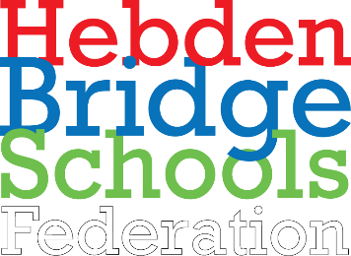 | 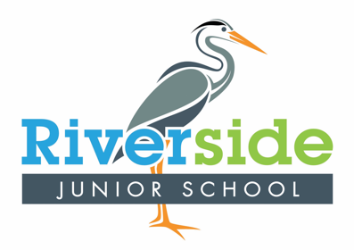 | Topic Overview KS2 (Year 5) - Spring 1 2021
Key Texts English | The Last Wild by Piers Torday
Subject | Science | Computing | Geography | History | Art & Design | Design & Technology | MFL | RE
NC  Objectives / links |  | - Pupils will:  - use technology safely, respectfully and responsibly;  - identify a range of ways to report concerns about content and contact.  understand computer networks including the internet; how they can provide multiple services, such as the world wide web; and the opportunities they offer for communication and collaboration  - use search technologies effectively, appreciate how results are selected and ranked, and be discerning in evaluating digital content.  - select, use and combine a variety of software (including internet services) on a range of digital devices to design and create a range of programs. |  | - Pupils will:  - continue to develop a chronologically secure knowledge and understanding of British, local and world history, establishing clear narratives within and across the periods they study. - They should note connections, contrasts and trends over time and develop the appropriate use of historical terms.  - They should regularly address and sometimes devise historically valid questions about change, cause, similarity and difference, and significance.  - They should construct informed responses that involve thoughtful selection and organisation of relevant historical information.  - They should understand how our knowledge of the past is constructed from a range of sources. | - Pupils will:  - develop their techniques, including their control and their use of materials, with creativity, experimentation and an increasing awareness of different kinds of art, craft and design.  - to create sketch books to record their observations and use them to review and revisit ideas  - to improve their mastery of art and design techniques, including drawing, painting and sculpture with a range of materials [for example, pencil, charcoal, paint, clay]  - learn about great artists, architects and designers in history. |  | - Pupils will:  - listen attentively to spoken language and show understanding by joining in and responding  - explore the patterns and sounds of language through songs and rhymes and link the spelling, sound and meaning of words  - engage in conversations; ask and answer questions; express opinions and respond to those of others; seek clarification and help*  - speak in sentences, using familiar vocabulary, phrases and basic language structures  - develop accurate pronunciation and intonation so that others understand when they are reading aloud.

Week/session | - Lesson QfL (Learning Intentions / Lesson Titles)  - Further QfLs linked to learning activities (additional questions for differentiated learning)  - Opportunities for Sparkle (see separate suggestions)
 | Science | Computing | Geography | History | Art & Design | Design & Technology | MFL | RE
Big Question | How do living things adapt to their habitats? | How can PowerPoint be a useful tool? |  | Why did the Vikings invade?  Trip to Yorvik | What is surrealism in art? |  | How are Spanish animal names different? | What is compassion?
Week 1 | What is a mammal?  How do mammals reproduce?  How do I identify a mammal?  What is the life cycle of a mammal?  Can mammals be split into groups? | What can PowerPoint be used for?  How is PowerPoint different to other Microsoft tools? |  | Who were the Vikings?  What was the Viking timeline?  Where did the Vikings originate from?  What are the known Viking settlements and homelands? | Who was Charlotte Perriand?  What did she create? |  |  | What is compassion?  Does everyone have compassion?  Does compassion look different to different people?  How do we show compassion
Week 2 | What is metamorphosis?  What animal groups go through metamorphosis?  Why do some animals only go through incomplete metamorphosis?  How can you identity the difference between an insect and amphibian? | How can slides and layouts improve a presentation?  What effects can be added onto slides?  Which slide layouts are most appropriate for the topic? |  | How did the Vikings fight?  What weapons did they use?  How can artefacts help us understand Viking battles?  What was important about the armour they wore?  How did they create the shields? | How do I design a piece of furniture inspired by Perriand?  What was the house above the water?  How does it relate to our local area? |  | How do we say animal names in Spanish?  Why do languages use different words for animals?  How can knowledge of root words help us learn Spanish animals names?
Week 3 | What is meant by sexual reproduction in plants?  How do we tell the difference between sexual and asexual reproduction?  What is a gamete?  How does plant fertilisation happen? | What is Word Art?  How can text boxes be used?  When might word art be effective?  How is word art different to normal text? |  | What did the Vikings trade?  What mode of transport did they use?  How were Viking long ships constructed?  What significant goods were traded? | What is an art movement?  What is Surrealism? |  |  | Is charity an example of compassion?  Can a ‘gift’ ever be selfless?  What is benevolent action?  Can charity ever not be compassionate?
Week 4 | What is asexual reproduction?  What are the functions of flower parts?  How are plants pollinated?  Why is only one parent plant needed for asexual reproduction?  What are the advantages and disadvantages of sexual and asexual reproduction? | How can pictures and graphics be inserted?  How are images saved safely from the internet?  Where are images stored?  How can images and graphics be inserted correctly onto a slide? |  | What was life like in Viking Britain?  How did the Vikings live?  What food did they eat?  Why were their homes called long houses?  What jobs did Vikings have? | How can I use digital photos to create a surreal portrait?  Who were Man Ray and Lee Miller?  Why were they important to surrealism? |  | How do Spanish animal names differ from English?  How do we say pig in Spanish?  Which Spanish words are similar to English?
Week 5 | Scientist study: Who was Jane Goodall?  What study methods did Jane use?  How did Jane impact on the chimpanzee’s behaviours?  How did observing the life cycle of chimpanzees’ help Jane?  Why are chimpanzees now endangered? | How can animation, video and audio be applied to a presentation?  What is the difference between animation, video and audio?  How do we insert animation safely? |  | What are Viking beliefs and mythology?  Who were the Viking Gods and Goddesses?  What is Valhalla?  Why was Odin so important to the Vikings? | Who was Leonora Carrington?  What can I create using her paintings and my imagination? |  |  | Why do we forgive?  What is forgiveness?  Is there ever a reason not to forgive?  Does everyone deserve forgiveness?
Week 6 | PowerPoint: How can I create awareness about endangered animals?  How can research help us make positive changes?  What information is needed to inform people of the change that needs to happen? | How can PowerPoint be used to present a topic?  What research is required to present a topic?  How can learnt PowerPoint skills be applied? |  | How did the Vikings fall?  How did King Alfred of Wessex defeat the Vikings?  How was the Battle of Hastings significant? | Who was Salvador Dali?  How can he inspire us to create surrealist clocks? |  | How do we form sentences in Spanish?  What does yo mean?  What impact does an accent have on the pronunciation of words?

