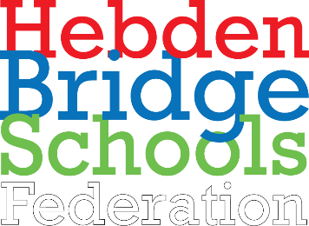 | 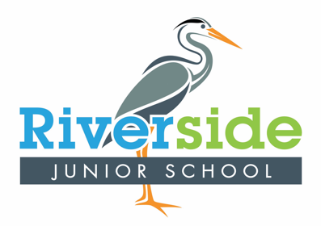 | Topic Overview KS2 (Year 5) - Summer 1 2022
Key Texts English | The Promise
Subject | Science | Computing | Geography | History | Art & Design | Design & Technology | MFL | RE
NC  Objectives / links | - Pupils should be taught to: -describe the movement of the Earth, and other planets, relative to the Sun in the solar system  -describe the movement of the Moon relative to the Earth  -describe the Sun, Earth and Moon as approximately spherical bodies  -use the idea of the Earth’s rotation to explain day and night and the apparent movement of the sun across the sky | - Pupils will:  - use technology safely, respectfully and responsibly;  - recognise acceptable/unacceptable behaviour;  - identify a range of ways to report concerns about content and contact. |  | - Pupils should continue to develop a chronologically secure knowledge and understanding of British, local and world history, establishing clear narratives within and across the periods they study.  - a study of an aspect or theme in British history that extends pupils’ chronological knowledge beyond 1066  - a significant turning point in British history, for example, the first railways or the Battle of Britain  - Children should understand how our knowledge of the past is constructed from a range of sources. | - Pupils should be taught to develop their techniques, including their control and their use of materials, with creativity, experimentation and an increasing awareness of different kinds of art, craft and design.  - Pupils should be taught:  -to create sketch books to record their observations and use them to review and revisit ideas  -to improve their mastery of art and design techniques, including drawing, painting and sculpture with a range of materials [for example, pencil, charcoal, paint, clay]  -about great artists, architects and designers in history. |  | - Pupils should be taught to:  -listen attentively to spoken language and show understanding by joining in and responding  - explore the patterns and sounds of language through songs and rhymes and link the spelling, sound and meaning of words  - engage in conversations; ask and answer questions; express opinions and respond to those of others; seek clarification and help*  - speak in sentences, using familiar vocabulary, phrases and basic language structures  - develop accurate pronunciation and intonation so that others understand when they are reading aloud. | - Describe and understand links between stories and other aspects of the Sikh communities, responding thoughtfully to beliefs and teachings that arise from them;  - Describe and make connections between different features of the Sikh religion and other world views, discovering more about prayer, celebrations, worship, pilgrimages and the rituals which mark important points in life.

Week/session | - Lesson QfL (Learning Intentions / Lesson Titles)  - Further QfLs linked to learning activities (additional questions for differentiated learning)  - Opportunities for Sparkle (see separate suggestions)
 | Science | Computing | Geography | History | Art & Design | Design & Technology | MFL | RE
Big Question | What is Puberty? | How is python used to create graphics? |  | How have the Victorians impacted life today?  SPARKLE: Victorian Day |  | How are mechanical toys made? | How do we tell the time in Spanish?
Week 1 | What changes happen to our bodies?  what is a lifecycle-what stage are you at now?  What is reproduction?  What is puberty?  Which body parts change during puberty? | What is python printing?  Why do coders often work in pairs?  What are the advantages of pair programming? What are the skills needed to work in a partnership? |  | What was Queen Victoria famous for?  Who was Queen Victoria?  How long did she reign for?  Why was she an influential woman?  Who was she married to? |  | How did the Victorians make toys move?  What toys did Victorians children play with?  What systems did they use to make them move?  What is the history of mechanical toys and how did they develop? (gears, pulleys, levers) | How to ask the time in Spanish?  What are the numbers to 12 in Spanish?  How do you tell the time from 1-12 o’clock?  When is es la and son las used?
Week 2 | What is puberty?  How can physical changes affect our emotions?  What is a period?  What are examples of menstrual products?  What is sperm? | What are inputs and variables?  What do we need to do to output variables?  How do we recognise a variable within the code?  How do we use variables to display the answer from the input command? |  | What was it like to be a child living in Victorian Britain?  What jobs did children have?  How did status affect opportunities for children?  What was Victorian education like for children? |  | What toy designs were popular in the Victorian era?  Why were certain types of toys popular?  Which modern day toys are similar in design and function?  How might we make a Victorian toy? | How do you say quarter past, half past and quarter to in Spanish?  How is dialogue sequenced when telling the time?  What does ‘y cuarto’ mean?  What does ‘y media’ mean?  What does ‘menos cuarto’ mean?
Week 3 | How do we talk about puberty?  Which changes are specific to males/females?  What is pubic hair?  When will puberty start? | What are python graphics?  What are turtle graphics?  How are they used to code lines and shapes?  What angle must we take to move a quarter turn? What problems might be faced when following instructions from a partner? |  | What was the industrial Revolution?  What is agriculture?  What does industrial mean?  How did Britain change?  Why did people migrate to towns from the countryside? |  | How are mechanical toys put together?  What is the criteria that our toy needs to meet for it to work effectively?  What is the importance of the different components?  How do they contribute to the functionality of our toy? | How is time told in five minute increments?  Which phrases are added when saying minutes past the hour or minutes to the hour?
Week 4 | What is the reproductive system?  What job do the uterus and testicles have?  What is a wet dream?  Why do penis’ become erect? | How are simple calculations created?  What are the symbols that show multiplication and division?  How numbers inputted correctly to create a total?  What is the effect of using quotes within calculation |  | What were factory conditions like?  What was produced from factories?  How much money did people earn?  Who worked in the factories? |  | What skills are needed to create a mechanical toy?  How do we use a saw safely?  What is the importance of sanding? | How to specify morning, afternoon and the evening timing?  When is the phrase de la mañana used?  When is the phrase de la tarde used?  When is the phrase de la noche used?
Week 5 | How do we get help and support through puberty?  What are healthy relationships?  What are good qualities for a relationship?  Why is self-respect important?  What emotional changes should I expect? | What have we learnt this term?  What is python printing?  What are variables and inputs?  What are python graphics?  How are simple calculations created? |  | What the Victorians invent?  What are the most famous inventions?  Who were famous Victorian inventors?  How did inventions change Britain for the better? |  | Did the mechanical toy work?  Does our toy meet the criteria?  Do the components carry out their function successfully? | How is time told on a 24-hour clock?  How does the sequence of phrases change when telling the time from a 24-hour clock to a 12-hour clock?

